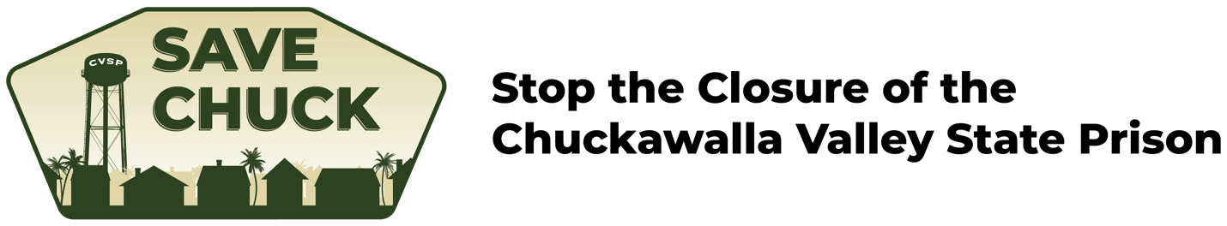

DATE

The Honorable Gavin Newsom
Governor, State of California
1021 O Street, Suite 9000
Sacramento, CA 95814

Dear Governor Newsom:

I am writing to urge you to reconsider the closure of Chuckawalla Valley State Prison in Blythe, California as proposed in your 2022-23 State budget.

Chuckawalla Valley State Prison plays a central role in the City of Blythe’s economy. As one of Blythe’s top employers, the prison supplies over 850 jobs, and is the main reason many residents make the City of Blythe their home. Blythe offers a low cost of living for full-time residents as well as families of the incarcerated. If inmates are forced to move, their families could face costly housing increases or even homelessness. Families of prison employees, many of which include Blythe’s teachers, public servants, and essential workers, would also have to relocate.

Additionally, Blythe residents would feel the impacts of the closure through a noticeable decline in the services the City would be able to provide to address business closures, loss of related jobs in sites such as school districts and decreased sales and property taxes from residents migrating out of the city.

PLEASE CITE HOW KEEPING CHUCKAWALLA IN OPERATION WOULD BENEFIT YOU OR HOW THE CLOSURE WOULD IMPACT YOU

Currently, 22.4% of Blythe’s population lives in poverty (Census, 2021) and the California State Auditor Dashboard ranked Blythe as 9th on the Distressed Cities Index, which ranks 430 California cities based on their financial health. If Chuckawalla Valley State Prison were to close, the economic effects on Blythe would be devastating.

I am not only asking to reconsider the closing of Chuckawalla, but to help in the proposition of an alternative - close California Rehabilitation Center in Norco instead. Community leaders in Blythe are - unlike nearly every other prison community - enthusiastic supporters of their local prison. This is in contrast to residents of Norco, California who have been advocating for the closure of the California Rehabilitation Center for years. As a comparatively expensive prison located in a busting area where prison closure would not have a significant effect on the local economy, the movement to save Chuckawalla Valley State Prison advocates closure of the CRC in lieu of Chuckawalla.

As Governor, you have a responsibility to act in accordance with the will of the people. You would be supporting a diverse coalition of Blythe residents, organizations, and legislators united around the mission to ‘Save Chuck’. You can learn more about this effort at SaveChuck.org. I thank you for your attention to this important issue and implore you to take a stand for the people of Blythe.

Sincerely,

[your name]

Cc:

Senator Steve Padilla
Senator Kelly Seyarto
Assemblymember Eduardo Garcia
Assemblymember Bill Essayli
Assembly Budget Committee
Assembly Member Philip Ting (Chair)
Assembly Member Vince Fong (Vice Chair)
Assembly Budget Sub-Committee #5, Public Safety
Assembly Member Mia Bonta (Chair)
Assembly Member Gregg Hart
Assembly Member Reginald Jones-Sawyer
Assembly Member Tom Lackey
Assembly Member Joe Patterson
Senate Budget Committee
Senator Nancy Skinner (Chair)
Senator Roger Niello (Vice Chair)
Senate Budget Sub-Committee #5, Corrections, Public Safety, Judiciary, Labor, and Transportation
Senator Maria Elena Durazo (Chair)
Senator Josh Newman
Senator Kelly Seyarto

